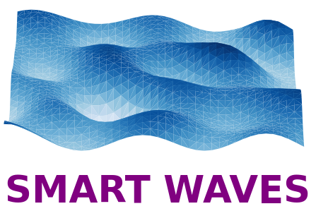


Applying for funding

« Smart Wave »

Background to the Smart Waves Major Programme
The convergence of diverse scientific cultures within the major "Smart Waves" programme has three concomitant strategic objectives
- Creation of a dynamic transdisciplinary community specific to PSL on the airwaves,
- Support for disruptive research areas that may encounter development challenges,
- Accelerating innovation.

Thus, Smart Wave is part of the broader mission to establish PSL as a global player in scientific excellence and cutting-edge research on the airwaves

Call type: Thesis funding

This program aims to fund a high-level seed project on a disruptive research topic that involves, in roughly equal parts, at least two teams from 2 different PSL laboratories. The maximum duration financed by "Smart Wave" is 36 months. Allowances may be considered. Only projects that already show potential candidates will be considered during the evaluation by the Scientific Council.

The evaluation criteria for the project are
- The evaluation criteria for the project are:
- The scientific excellence and disruptive nature of the proposal requiring funding from the major programme,
- New collaboration between PSL players,
- Initiating nature of the proposed work,
- The complementarity and adequacy of the teams involved in the project. Involvement of junior researchers,
- The quality of the applications proposed.

If the steering committee deems it necessary, a hearing may be organised to decide between the best applications. In any case, the leaders of the selected projects will have to launch an advertisement to recruit the best candidate.

Documents to provide:
- This fact sheet
- CV and Master's transcript of one or more prospective candidates
- Candidate's cover letter

Submission deadline: April 18, 2025

Submit documents to: julien.derosny@espci.fr

Identity of the project:

Project title:

Acronym:

Thematic axis:
Selection of the main thematic axis in which the project is part (and if relevant, a secondary thematic axis)
- Information and complexity
- Communications, analogue computing and wavefront shaping
- Quantitative Imaging
- Innovative materials for waves

Summary of the project in a few lines:

Scientific leaders and project partners

There must be at least 2 partners from 2 different laboratories.

PSL Partner A (in charge of recruitment)
- PSL Unit Name:
- Scientific Leader:
- Doctoral School of Recruitment
- Name:
- Forename:
- Email:
- Telephone:

PSL Partner B
- PSL Unit Name:
- Scientific Leader:
- Name:
- Forename:
- email:
- Telephone:

Other partners

New collaboration
Is this a new collaboration between 2 or more partners? Yes / No
If not, briefly describe previous collaborations.

Project description:

Scientific objectives, challenges with regard to the state of the art, disruptive nature (1/2 to 1 page)

Methodology, work plan (1/2 to 1 page)

Complementarity of the teams involved (1/4 to 1/2 page)

Work Environment
This funding only covers the salary and a maximum of 3000 euros in mission expenses. Specify the work environment and the resources available for the smooth running of the post-doc. Note that it is possible to apply for funding separately for equipment whose evaluation will be carried out independently.

Expected impacts and valuation of results (1/4 to 1/2 page)

